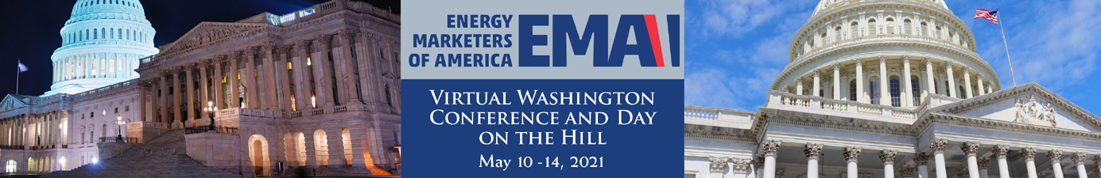

CDL Driver Shortage

Issue Background
The shortage of qualified drivers with Commercial Driver’s License (CDL) has become a serious problem in recent years. Some of the factors contributing to the shortage are the aging workforce, more job alternatives, regulations making it more difficult to obtain a CDL, 21 years old minimum age requirement, drivers exiting the market because of lifestyle changes and industry growth which requires more drivers. According to surveys by American Trucking Associations (ATA), the average driver age in the for-hire over-the-road truckload industry is 49. Over the next decade, the trucking industry will need to hire roughly 898,000 new drivers, or an average of nearly 90,000 per year.

However, the often-overlooked factor that contributes to the CDL driver shortage is finding qualified applicants. In some cases, carriers must reject 90 percent of applicants because they fail to meet at least one of the prerequisites to be qualified to drive. There are many barriers to entry for new drivers: age requirements, CDL testing standards, strict drug and alcohol testing regimes and, perhaps most importantly for many carriers, unrealistic requirements for spotless driving records.

DRIVE-Safe Act
The DRIVE-Safe Act (S. 659) (H.R. 1745) reintroduced by Rep. Trey Hollingsworth (R-IN), as well as Sens. John Tester (D-MT) and Todd Young (R-IN), would allow drivers 18 and older to operate across state lines if they meet rigorous training requirements — at least 400 hours of on-duty time with 240 hours of driving time, with an experienced driver training them. Training would also be restricted to trucks equipped with active braking systems, video monitoring systems and speed limiters set to 65 mph or slower.

Although EMA drivers transporting fuel would not be covered under the DRIVE-Safe Act since drivers must be 21 to qualify for a hazardous materials endorsement (HME), EMA supports the bill because it would expand the number of CDL drivers overall, some of whom may choose to obtain an HME in the future.

S. 659 Cosponsors: Senators Todd Young (R-IN), Jon Tester (D-MT), Joe Manchin (D-WV), Tom Cotton (R-AR), Angus King (I-ME), Kyrsten Sinema (D-AZ), Cindy-Hyde Smith (R-MS), Jerry Moran (R-KS) and Jim Inhofe (R-OK).

H.R. 1745 Cosponsors: Rep. Trey Hollingsworth (R-IN) introduced H.R. 1745 along with Jim Cooper (D-TN), Bruce Westerman (R-AR), Henry Cuellar (D-TX), Troy Balderson (R-OH), Elissa Slotkin (D-MI), Darrin LaHood (R-IL), Jared Golden (D-ME) and Ashley Hinson (R-IA).

“THE ASK” Committees: House Transportation and Infrastructure; Senate Committee on Commerce, Science and Transportation

Urge lawmakers to cosponsor the DRIVE-Safe Act (S.659) (H.R. 1745).

EMA STAFF CONTACT: Rob Underwood, runderwood@emamerica.org; Sherri Stone sstone@emamerica.org

